**Target frame Barcode TAG identification software**

Windows Setup

*Installation and Compilation*

Author: Dragos C. Popescu

Contact: [dragos.popescu@eli-np.ro](mailto:dragos.popescu@eli-np.ro)

Coordinator: Mihail O. Cernaianu

Date created: 07.03.2017

|  |
| --- |
| **Disclaimer !!!**  The source code was compiled under **Windows 8.1 64bit** using:   * **Visual Studio Express 2012** * **OpenCV 2.4.13** * **Zbar 0.10**   but it should work using any other Windows setup. |

**1. Visual Studio Setup**

* Download and install the latest version of **Visual Studio Express** from:

<https://www.visualstudio.com/vs/visual-studio-express/>

**2. OpenCV Setup**

* Download  **OpenCV 2.4.13** installer from:

<https://sourceforge.net/projects/opencvlibrary/files/opencv-win/2.4.13/opencv-2.4.13.exe/download>

|  |
| --- |
| **Warning !!!**   * This archive contains only VC11 and VC12 libraries. * For VC14 libraries you should download the following installer:   <https://sourceforge.net/projects/opencvlibrary/files/opencv-win/2.4.13/opencv-2.4.13.2-vc14.exe/download>   * For any other distribution you have to build your own libraries from Source Files using the following instructions:   <http://docs.opencv.org/2.4/doc/tutorials/introduction/windows_install/windows_install.html> |

|  |
| --- |
| **Warning !!!**  Because **Zbar** library is only **32bit** version you have to use only **x86 OpenCV** version. |

* Extract **OpenCV** archive to any desired location.
* **Configure Environment Variables:**
* Add to System Variables the path of the **vc11** folder from **x86** folder from **build** folder from **opencv** folder you have extracted.

*ex: %OPENCV_DIR% - D:\opencv\build\x86\vc11*

* Add to Path the location of the **bin** folder from **vc11** folder.

*ex: %OPENCV_DIR%\bin*

**3.Zbar Setup**

* Download **Zbar** installer from:

<https://sourceforge.net/projects/zbar/files/zbar/0.10/zbar-0.10-setup.exe/download>

* Run the installer.
* Make sure to install all the components:

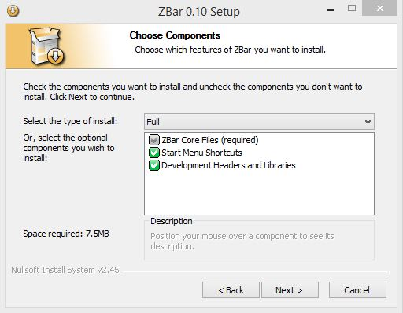

* Install **Zbar** in the default directory:

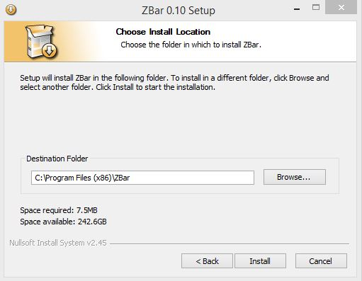

* **Configure Environment Variables:**
* Add to Path the location of the **bin** folder from **Zbar** installation folder:

*ex: C:\Program Files (x86)\ZBar\bin*

**4. Visual Studio (VS) Project configuration**

* In VS create a new *empty* **Win32 Console Application** project:

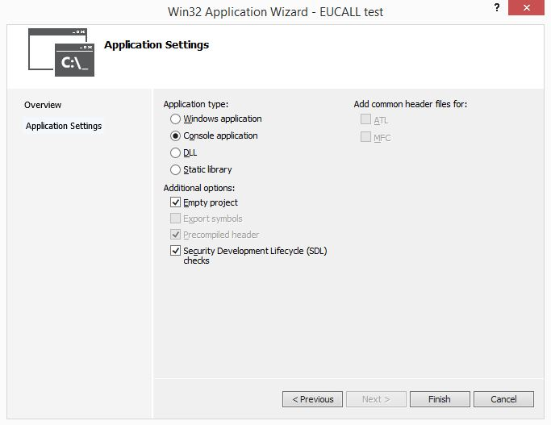

* Configure the project to **Release** from the upper side in VS:

C:\Users\Dragos Popescu\Desktop\Capture.JPG

* Right-click on the application name from the **Solution Explorer** (upper-right side in VS) and click **Properties**:

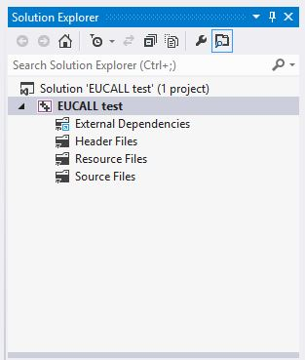

* Go to **Configuration Properties** >> **C/C++** >> **General** >> **Additional Include Directories** and add:

*$(OPENCV_DIR)\..\..\include*

*C:\Program Files (x86)\ZBar\include*

* Go to **Configuration Properties** >> **Linker** >> **General** >> **Additional Library Directories** and add:

*$(OPENCV_DIR)\lib*

*C:\Program Files (x86)\ZBar\lib*

* Go to **Configuration Properties** >> **Linker** >> **Input** >> **Additional Dependencies** and add:

*libzbar-0.lib*

*opencv_calib3d2413.lib*

*opencv_contrib2413.lib*

*opencv_core2413.lib*

*opencv_features2d2413.lib*

*opencv_flann2413.lib*

*opencv_gpu2413.lib*

*opencv_highgui2413.lib*

*opencv_imgproc2413.lib*

*opencv_legacy2413.lib*

*opencv_ml2413.lib*

*opencv_nonfree2413.lib*

*opencv_objdetect2413.lib*

*opencv_ocl2413.lib*

*opencv_photo2413.lib*

*opencv_stitching2413.lib*

*opencv_superres2413.lib*

*opencv_ts2413.lib*

*opencv_video2413.lib*

*opencv_videostab2413.lib*

|  |
| --- |
| **Warning !!!**  If using other **OpenCV** version you have to modify accordingly the name of the libraries |

* Click **Apply** >> **Ok**.
* In **Solution Explorer** under the name of the application right-click on **Source Files** and click on **Add** >> **New Item** >> **C++ File (.cpp)** and name it **main.cpp**.
* In **main.cpp** copy the **Source Code** for **TAG identification software** and save it.
* In **Solution Explorer** right-click on the application name and click **Build**.
* The application should build without any errors.

**4.Testing / using the application**

* Open **Command Prompt** and navigate to **Release** folder from the folder where you have created the project.
* There should be a **.exe** application created by the compilation process.
* You need to have in the same folder an input image with a barcode.
* Run:

*APP_NAME.exe IMG_NAME.jpg 1*

if you want to display an image with the Barcode identified, otherwise run:

*APP_NAME.exe IMG_NAME.jpg*

|  |
| --- |
| **Warning !!!**  The application can be moved to any other location and renamed |

|  |
| --- |
| **Warning !!!**  If the name of the application or the input image contains spaces, you have to provide them inside commas:  “*APP NAME.exe” “IMG NAME.jpg” 1* |